COLOR PALETTE
Types of Inks
- Waterbase Discharge - our standard ink - can also PMS match. May have discharge issues and not print 100%. Bleaches the dye color out of the shirt and replaces with ink color, so it feels super soft.
- Non-discharge - does not have the discharge powder mixed in, so it doesn't bleach out the garment dye. Will not print as vibrant as other ink types
- High Solid - currently not in use - still a waterbase ink but prints 100% bright, comes in our ink colors or we can PMS match the color. Does have a slight feel to the print. *** Max 2 inks
- Plastisol - the industry standard - plastic on a shirt. Typically only used when the client wants their print 100% bright OR if we are printing on a garment that has a bad makeup. Must choose from the 16 in-house plastisol options (can be PMS matched in special cases). *** Max 6 inks

Discharge
Discharge is the percentage that the bleaching agent in our ink is able to bleach out the dye of the garment. Low discharge means that the ink will print on the shirt with a faded, "vintage" look. This can be caused by the garment makeup - if it is not an in-house garment, check the product description. REFER TO "DISCHARGE RATINGS" MONDAY BOARD.
- In-house apparel colors with low discharge:
  - H Royal - 60%
  - H Red - 70%
  - H Purple - 60%
  - H Graphite - 90%
  - H Kelly - 80%
  - Black - 80%
  - H Honey - 90%
  - H Burgundy 90% NO VINTAGE STICKER
  - H Black - 90% NO VINTAGE STICKER
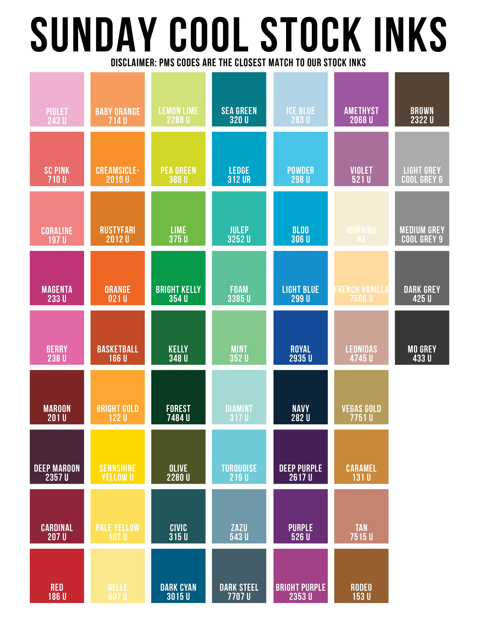
Note: There are pre-made swatches for all of these garments. Search for them in the Color Swatches Dropbox Folder

PMS Matching
PMS is a color matching system that is used by most printers. It allows people in different places to create the same colors by comparing to the numbers in the Pantone books. We use two different types of Pantone swatches: coated and uncoated.
- Uncoated - used for waterbase - noted as the color's number followed by a U
- Coated - used for plastisol - noted as the color's number followed by a C
- Hex code - a six-character code that represents a color on a screen - not a PMS code
If a client provides a PMS code, we need to double check that the number they gave us is accurate to how they want it to look, and we need to make sure we are using the correct Pantone book depending on the type of ink we are using. If a client provides a hex code, we need to create an object of that color in illustrator and then compare the color on our screen to the appropriate Pantone book.
Plastisol
Any garment:
- 1 color 1 location minimum 24 pieces
- multi location or multi color 36 pieces
- 144+ PMS

NOTES:
- Front Door lead times apply
- EXCEPTIONS to the above will be considered for National Accounts and other opportunities at Leadership discretion.

TULTEX SHIRTS HEX CODES

Heather Military Green - 5B6051
Heather Red - A0242D
Heather Burgundy - 6D314A
Heather Royal - 324684
Heather Denim - 2F3849
Heather Charcoal - 38393A
Heather Graphite - 262626
Heather Purple - 4A3666
Heather Kelly - 05995A
Heather Mint Julep - B6F2B6
Heather Sky - AADFE0
Heather Grape - 965670
Heather Melon - FFA05F
Heather Honey - F4AD3B
Heather Pumpkin - B27042
Heather Mudd - 705B41
Heather Gator - 436C4A
Heather sAGE - ADCABA
Heather Tan - CAB293

Youth Companions
Some of our in-house shirts are not available in youth sizes. This information (and other info about the garments we carry) can also be found at https://www.sundaycool.com/apparel.
- Shirts that ONLY come in adult sizes:
  - H Graphite
  - H Kelly
  - H Orange
  - H Purple
  - H Pumpkin
  - H Slate
  - H Mudd
  - H Gator

Ink/Shirt Combinations that do NOT work - subject to change
- H Military - olive
- H Red - red
- H Burgundy - maroon, deep maroon, no magenta text
- H Orange - orange
- H Royal - royal, dark cyan
- H Denim - mo grey
- H Charcoal - mo grey, olive
- H Graphite - black, mo grey
- H Purple - purple
- H Kelly - kelly
- H Mint Julep - mint
- H Sky - turquoise, zazu, ice, powder, diamint, no light grey text
- H Grape - br purple, amethyst, no magenta text
- H Melon - bb orange, br gold, creamsicle
- H Honey - br gold, creamsicle
- H Pumpkin - rodeo, caramel
- H Sage - turquoise, zazu, ice, powder, diamint, no light grey text, lemon, sage
- H Tan - Vegas
- H Mudd - Brown, Rodeo, Me Grey
- H Gator - Forest

